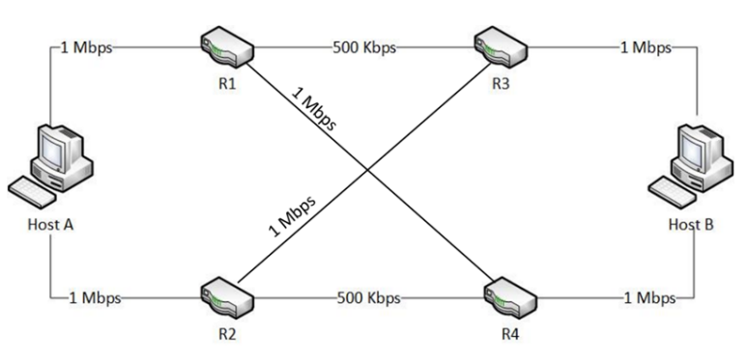

R1-eth1

192.168.51.1

R3-eth1

192.168.51.2

R1-eth0

192.168.50.2

R3-eth0

192.168.53.1

R4-eth2

192.168.52.2

R3-eth2

192.168.54.1

R2-eth2

192.168.54.2

R1-eth2

192.168.52.1

HB-eth0

192.168.53.2

HB-eth1

192.168.55.1

R4-eth1

192.168.55.2

R2-eth1

192.168.57.1

R2-eth0

192.168.56.2

HA-eth0

192.168.50.1

R4-eth0

192.168.56.1

HA-eth1

192.168.57.2